Spring 2025 WPA-AAPT
22 March 2025
Seton Hill University
Agenda (Subject to Change)
8:30 – 9:30 - Registration
9:30 – 9:45 - Welcome
9:45 – 10:30 – Talks (Link for more information WPA-AAPT 2025 Spring Meeting)
“An Overview of Lab Problem for Undergraduate Computational Physics Courses” Matteo Luisi, Westminster University
“Phantastic Physics” Kathy Willard, Monessen High School
“Light and Vision: Developing a Course in Optics for non-STEM Undergraduate Students” Michael Antonacci, St. Vincent College
10:30 – 10:45 – Break
10:45 – 11:15 - Talks (15 minutes per talk)
“Adapting Learning-Objective-Based Grading for a Sophomore Math Methods Course” DJ Wagner, Grove City College
“Consequences of Osteoarthritis from a Dynamics Perspective” Stan Sobolewski, Indiana University of Pennsylvania
11:15 – 11:45 – Break, Posters, etc
“Interactive Learning at the Angelo J Talani Planetarium: A Diverse Pedagogical Approach to Teaching Astronomy” Andrew Joyce, Adrianna Battaglia, Liam Dicken, St. Vincent College
“Catalytic SABRE 1H Hyperpolarization of Pyridine in Aqueous Media by [IrCl(COD)(ITEG)]” Antony Sparta, St. Vincent College
11:45 – 12:45 – Lunch at Lowe Dining Hall ($12.40 per person, cash or card accepted)
(Packed lunches are also welcome)

1:00 – 2:00 – Keynote speaker
Dr. Meagan Sundstrom is a Cotswold Foundation Postdoctoral Fellow at Drexel University, working with Drs. Eric Brewe and Adrienne Traxler (University of Copenhagen). Her current research uses social network analysis, classroom observations, and conceptual inventory data to better characterize different active learning pedagogies used to teach undergraduate physics. Previously, Meagan completed her PhD at Cornell University working with Dr. Natasha Holmes. Her dissertation research used social network analysis to understand undergraduate physics students' interactions with their peers and recognition of their strong peers, with a focus on the role of student gender in these networks. She also conducted qualitative research related to student epistemic framing, the ways in which students expect to construct knowledge, in non-traditional physics labs. Meagan earned a Bachelor's degree in Mathematics-Physics from the University of Connecticut in 2019. There, she conducted research operationalizing the construct of Intellectual Humility in physics education research.
“Rethinking the role of instructional physics labs”
Instructional physics labs often aim for students to observe classic physics phenomena. In this talk, I will describe research that demonstrates significant issues with such concepts-based labs, including limited impacts on student learning of the concepts being observed and student expectations that knowledge comes from authority. I will then describe a new approach to lab instruction that focuses on developing experimental skills. I will also present data about student expectations for how they construct knowledge in skills-based labs and the extent to which students engage in peer interactions in concepts-based versus skills-based labs.
2:15 – 2:30 – Business Meeting
AAPT National Update – Abigail Bogdan
Budget Report – Stan Sobolewski
Future Meetings – Fall 2025 – Virtual
Spring 2026 – Grove City College (POC DJ Wagner)
Fall 2026 – Virtual
Spring 2027 – Westminster (POC Matteo Luisi)
Election of Secretary

Driving/Parking Instructions
GPS:
Seton Hill University (main campus)
1 Seton Hill Drive
Greensburg, Pa. 15601
Directions to campus:
From the East, Taking Route 30 West:
Pass Westmoreland Mall and exit Route 30 by staying in the right lane towards the Greensburg Business District. This becomes W. Otterman Street. Continue on W. Otterman past the Palace Theatre and Seton Hill Performing Arts Center and turn right on College Avenue (the Seton Hill Arts Center is on the far corner). Continue on College Avenue through the tunnel. Seton Hill University’s main entrance is immediately after the tunnel on the left.
From the West, Taking Route 30 East:
Follow Route 30 East to the Pittsburgh Street Exit. Follow East Pittsburgh Street to Bell Way and turn left. Bell Way becomes College Avenue at the following intersection. Continue on College Avenue through the tunnel. Seton Hill University’s main entrance is immediately after the tunnel on the left.
From Pittsburgh:
Take the Pennsylvania Turnpike (Route 76) east to Exit 67 (US 30, Irwin). Then follow directions from the West (above).
From the Northeast:
Follow Route 22 West to Route 66 South (toll road). Take Exit 6 (Greensburg/Irwin, Route 30). Turn left onto Route 30 East. Then follow directions from the West (above).
From the South:
Follow Route 119 North to New Stanton. Continue on Route 119 North through Youngwood and downtown Greensburg. This becomes Main Street. Turn left on W. Otterman Street (Greensburg Courthouse will be on your left). Continue on W. Otterman past the Palace Theatre and Seton Hill Performing Arts Center and turn right on College Avenue (the Seton Hill Arts Center is on the far corner). Continue on College Avenue through the tunnel. Seton Hill University’s main entrance is immediately after the tunnel on the left.

Meeting Location
The meeting will be held in the JoAnne Woodyard Boyle Health Sciences Center (Building 14 on attached map). We will meet in Boyle 167A/B. You can park in Lots A, B, or C (highlighted on the map). You will drive up Seton Hill Drive, and, once you pass the Boyle Science Center, you will be in Lot A. To get to Lots B and C, continue to the end of Lot A and turn left at the stop sign and then immediately left into Lots B & C.

The main entrance to Boyle (which you'll pass before reaching Lot A) as well as the lower entrance (by Lots B & C) will be unlocked from 8-10a. If you come in the lower entrance, you can either take the stairs or the elevator up to the first floor. If you will be arriving outside of 8-10a, please email Abby Bogdan (abogdan@setonhill.edu) to arrange to be let in.
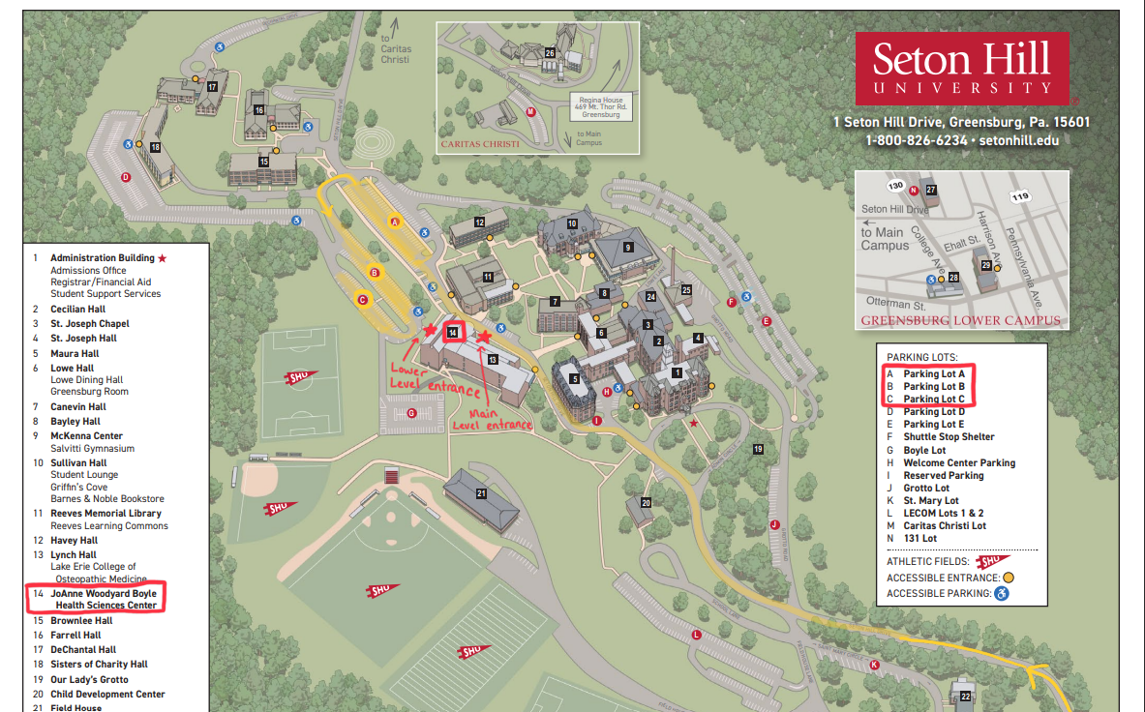
Lunch Information
Lunch will be in Lowe Dining Hall. You can purchase food at the cafeteria ($12.40 per person, either cash or card) or you can bring your own packed lunch.

